2014 Year end report Foundry Lane Surgery.

Another busy year at the surgery. The PPG has met at intervals to discuss ideas and developments and, on an anonymised basis, complaints or other difficulties. In general the meetings are supportive of the surgery and its team.

We have welcomed Dr Mishra working for us every Friday, she has a lot of experience gained working in Ilkley before moving down to Leeds.

Our Phlebotomist Sarah has completed a course to become a Health Care Assistant and a specialist course in smoking cessation so we are once again able to offer an in house smoking cessation service.

In reception we have been joined by Mandy and Denise who have fitted in very well and quickly adapted to their new roles.

The physio service has been well received and now runs on Tuesday and Thursday afternoons – and has already proved so successful that there is already a waiting list- a victim of its own success. Midwifery services continue to be offered and may expand further once more midwives are available in the community.

There has been an improvement in access to results of tests and similar both done in Hospitals or done in surgery but results not sent through promptly. Using the enhanced access allows Dr to directly get results from the hospital server. There have been occasions when it has failed because the server is down but overall it has made a difference.

Investment in the fabric of the building as far as our lease permits has continued with the installation of new lighting in the main corridor – this not only improves the lighting now but because the lights are much more eco friendly helps make the building more sustainable for the future . A further programme of investment is planned including improvements to the heating and the flooring in the main corridor will be replaced over the summer. It would have been a waste to have it done before the lights etc and we have to find a time when we minimise risk to users of the building while the work is being done.

We have continued to work with local groups; enhancing this through meeting them at Multi Disciplinary team meetings which have extended to include more third sector involvement. Additionally we actively participate in the South Seacroft Health Group a grouping of statutory bodies, 3rd sector organisations, tenants groups, local schools and indeed any group who wish to contribute to health in the wider context.

A gardening group was set up and the weather was kind! With the support of the council we used the deep tubs which previously had been used for flowers to grow quite a variety of food as a demonstration site. Staff from the ‘Back to Front’ gardening team attended and ran mini workshops and distributed seedlings and for those who wanted it additional support in terms of compost and further seedlings was provided at their home address. Free fresh food, zero food miles, fresh air and meeting with like minded people; a very positive experience.

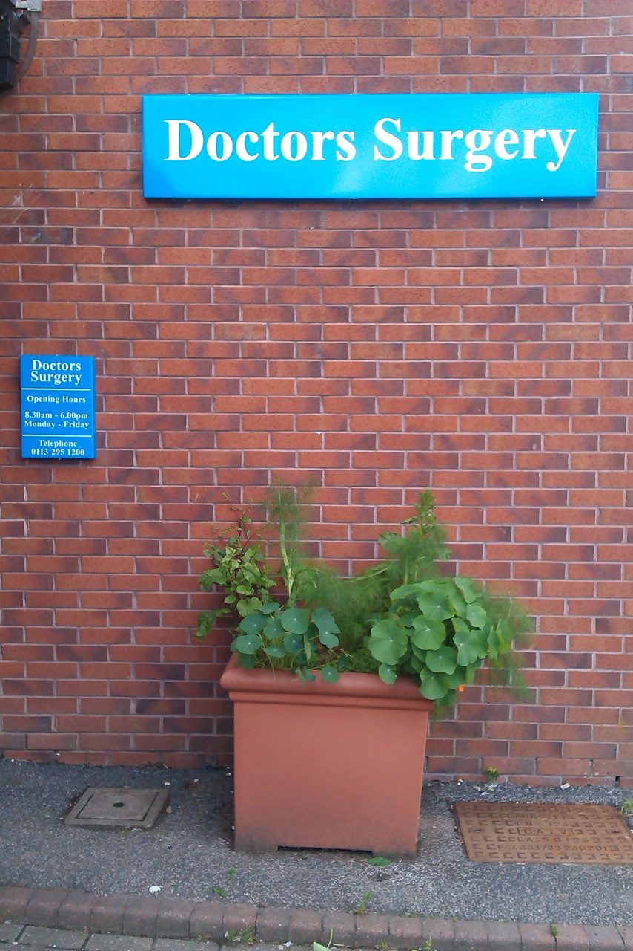

Our tubs produced lettuce, herbs, beans, chard and the manager’s favourite Fennel as well as having nasturtiums for colour and eating in salad.

Looking forward:

One major problem identified both by the PRG and the South Seacroft Health Group was the level of alcohol abuse and all the problems which that brings with it in the local area. A successful bid was submitted using the ‘2% bid’ process and from mid April we will be working closely with the Crypt and have an in house alcohol worker/counsellor for two sessions per week. His remit will include not just alcohol reduction but include support with maintaining tenancies where these are under threat, money management, useful distraction techniques, self esteem and development. We are working with the Crypt because of their experience and capacity to deliver the service which will have the backing of all the resources and expertise available at the Crypt itself. The last few details are in the process of being sorted out but we hope this will be a very useful addition to the services available.

The Crypt is a 3rd sector service aimed at helping people of all backgrounds who find themselves in difficulty with a primary focus on alcohol abuse. Based in Leeds city centre near the Leeds General Infirmary it was initially set up over 100 years ago and they have a wealth of knowledge and experience in helping people both directly with their levels of alcohol consumption and all the other problems it can bring. Anyone can attend to get a meal at lunch time and they also have some residential capacity. Having visited it as part of the process of setting up the service the Practice Manager found it hugely interesting and inspiring.

Dr Pearson will be reducing his hours from October – these hours will be taken up by Dr Rushforth increasing his hours.

Patient survey feedback.

The survey was based on a simplified and shortened ‘Calibre’ survey but still including question re DNA and including ‘soft skills’ questions based on those which are included in the questionnaires used by GPRs for their e Portfolios.

230 surveys were given out only 106 were returned and many of those were only partially completed. Surveys were given out over a period of several weeks to try to get a wide cross section of patient response, patients had the option to fill surveys in at the surgery or take them away.

The practice was rated as excellent by 60 patients, good by 43 and ok by 3 patients.

Of those who identified them selves as carers 25 thought we provided enough information to meet their specific needs while 2 people thought we provided some but not enough information.

In regard to their specific health needs 17 thought the practice always met their specific needs while 3 thought their needs were met sometimes but not always. No suggestions for improvement were received as to how we might better support carers.

Appointments;

Suggestions as to how it could be made easier to make an appointment:

To be put in queue if the line is busy.

Another telephone line would be useful sometimes the line can be engaged for fifteen – twenty minutes.

I have no problem with current system.

I am happy as it is

To be able to book several days in advance.

Don’t know

So you can ring to book an appointment at any time not just mornings.

Don’t think you can

By answering the phone at 8.30am

On line booking – but just found out that I can.

More phones at 8.30am

You can’t.

It would be very easy if I was seeing any Dr but I just see the same one always.

On line booking

Online appointments

Open the phone lines at 8.00am & having 2 or more lines.

Not having to ring at 8.30am as line always seems busy and then there ain’t any appointments left, this has happened to myself.

I think it is already easy.

Reflections:

We do realise this is a source of frustration for people especially first thing in the morning but our divert ends at 8.30 and the phones are answered continuously from that point. Phone bills are checked to ensure that the divert is operating as it is supposed to; the latest it has been in reverting to the surgery during the period of Jan- Feb 2014 is 8.31am Several people suggested that we have more phone lines first thing in the morning – we did increase the number by 50% a couple of years ago but equally we have comments that the appointments are all gone too early. So either way someone is disappointed. We are not complacent and are undertaking a major skills mix/staffing review starting from mid March but at present we have no way of accurately predicting demand so it makes it difficult to ensure that everyone can get an appointment exactly when they want it. Appointments with the six core Drs are usually available to book up to 6 weeks in advance and we do recommend that if patients know they need to come back to see a Dr they make an appointment before leaving. If there are concerns about remembering, text reminders can be sent to phones but that system only works when patients keep the practice informed if they change their number.

On line appointment booking has been available since December 13 as featured in our newsletter and in notices in waiting area.

A queuing system has the problem that it will cost money to hold the line and not everyone is able to afford to or may not have credit or power on their mobile to do so.
Opening the phone lines earlier would, we feel, only mean lots of people ringing earlier. We have had 2 lines on reception alone for many years as well as admin office phones.

We are aware that there has been a shortage of nurse appointments at some points this last year. Our previous Health Care Assistant had moved on for family reasons and it took us some time to recruit a replacement. The person recruited was a qualified phlebotomist but did then need training for a wider role so the impact of her recruitment was not immediately apparent. We felt this was safer and in everyone’s best interest rather than employing someone who was not properly qualified. Happily she passed and is now a qualified HCA so the difficulties that there have been in regard to getting nurses appointments should be eased though once again appointments with nurses can usually be booked up to 6 weeks in advance.

16 people admitted to wasting appointments but only five gave an explanation. People failing to tell us they are not going to attend appointments seriously affects our capacity to see other patients. Anyone can be held up/forget an occasional appointment but those who miss multiple appointments are removed from our list. It is not unusual for there to be 200 or more appointments wasted in any month. This is the equivalent of 10 full surgeries of appointments wasted. The current system, agreed with the patient representation group, is that 3 wasted appointments and a letter is sent and 4 or more leads to the individual being considered for removal.

Reasons given for wasting appointments were:
Overslept;
Busy with school work and dance after school;
Written down wrong – my error;
I might have been in a fit,
It was a very long time ago and I was suffering from depression and was forgetful about appointments. The reminder service now is brilliant:

Information and feedback:

The overwhelming majority of respondents were either very happy or happy with information provided and with the opportunity to provide feedback. Feedback can be provided to any member of staff at anytime, appointments can be booked, subject to other commitments, with the practice manager if anyone has a concern or a suggestion. No suggestions were made to improve information or the opportunity to feedback.

Services:

A very large majority rated the practice well in regard to the services offered, though disappointingly there were a number of respondents who felt that the receptionists were only ‘sometimes’ polite and helpful. This has been addressed by training at the end of 213, by individual and collective meetings January and February 2014 and further training is scheduled for April in addition to which all staff will be completing an online course in customer care.

Some concerns were expressed that individuals could be overheard by others when speaking to receptionists. Additional signs have been put up since the beginning of the year and we do ask all patients to give those in front time to complete their transactions. Additionally there is a side window in reception which patients can use if they are concerned re their privacy

Involvement in treatment decisions:

A huge majority were as involved as they wished to be in decisions about heir treatment, no respondents were less involved than they wished to be in their treatment decisions. Rather sadly 3 people felt they were more involved than they wanted to be, 3 did not want to be involved at all and 5 people thought it was not relevant. This high level of satisfaction with involvement in decisions about their own care was reflected in very high levels of patients being happy that they knew what their medication was for, how to use it, possible side affects and management of any side affects.

Suggestions for improvements:

Up to date mags: We usually have the weekly updates of Stylist magazine – aimed at women and Shortlist aimed at men. We have no way of controlling whether magazines are removed from the waiting room.

Priority for workers in late appointments: This presents some difficulties since we have no way of knowing who does or does not work Patients who specifically need late appointments need to tell the receptionists why and reception staff have been reminded about being as accommodating as they can, though obviously if future appointments are made when leaving the premises it is often easier to accommodate specific requests. Given the pressure on resources we cannot at this time afford to set appointments aside for anyone group of people in case they are not fully used.

Telephone assessment service: we have had this for over 5 years.

Longer opening hours and open at week ends: Our difficulty with this is that a Dr on duty on Saturday is a Dr NOT on duty at some other time in the week. The total number of appointments available in any week would not increase. When we did previously open on Saturday very often Dr and staff sat and waited for patients who had booked appointments and none of them turned up so it was decided to concentrate resources during the week. Longer opening hours and week end opening may become the norm as time goes forward but the difficulty will be staffing them. Recruitment into general practice is falling fast- a constant barrage of ill informed abuse from the gutter press with increased demand and falling resources means that GP is not an attractive career option. More than 90% of all NHS work is done in general practice with fewer than 9% of the resources.

More courses: we are able to signpost people to courses when they exist but we have no influence at all over what courses are provided. There a lists of available courses along with contact information on display in the waiting areas. Less formally health related courses e.g. healthy cooking on a budget are advertised on our newsletter as we become aware of them.

A path from number 11 bus stop: We can suggest this to the council but it would need to go through planning permission system and similar. Additionally we cannot be sure that the bus stop will always be in the same place nor could we take responsibility for maintaining any path.

Bacterial handwash on entry: There is anti bacterial hand gel for patient use immediately next to the signing in screen.

A number of respondents were kind enough to add positive comments a selection of which are below.

I can’t fault either doctors or reception staff they are always accommodating I have several health issues and I feel well looked after.

I am happy as it is

I have no problems with it.

Fantastic

Excellent

No change needed.

This practice has always done brill for my family means a lot to be able to talk to Drs, don’t like going to new Drs but new ones are good too.

I find it great and wouldn’t change nothing.

No improvement needed.

Much better than previous GP. (name of GP practice supplied but redacted since we have no wish to be sued).

Other services used were the out of hours emergency service which was rated as excellent, as were the tissue viability service, and an Xpert patient course in Diabetes.

There would appear to be a deficit in communication with some patients about our services. It is hoped that as a first step we can get the digital information board in reception working consistently but if patients do not read newsletters/leaflets/information provided at registration it is difficult to see alternatives. Again this year one person suggested we get notice boards in waiting area, there are boards all round the walls in the main waiting area, as well as immediately opposite the seats in the small secondary waiting area.

AND Finally a plea

If you move house or change your phone number let us know. There have been occasions throughout this year when for reasons ranging from their own or family illness, to stuck in traffic because of an accident, though to being called to an emergency meeting – child protection- Drs or nurses have not been available at short notice. If we cannot contact you to re organise your appointment then we will try to accommodate you by moving you to another nurse or Dr at similar time. A couple of people have reacted angrily to this but no one has come up with an alternative solution. Records are available to each Dr using the system so even if the person you are moved to is not your usual Dr they will be able to offer you treatment.

This report was discussed on 11th March with the PRG who suggested the following amendments/additions/ made the following comments.

Generally the report was felt to be a fair reflection of our activities and more positive than last years.

Most of the services requested by patients already exist but other than trying to get the information screen to work more consistently – training on this will happen in May/June – no one had any suggestions re increasing/improving information flow. There was incredulity that someone thought we had no notice boards.

Appendix:

The figures: those of a sensitive disposition may wish to stop reading now

Frequency of attendance:
3 people attended weekly, 36 monthly, 42 every few months and 25 attended as needed.

Appointment booking.

5 people booked their appointments in person, 83 booked them over the phone and 6 booked by other means- no one actually said they booked on line but the number of those registering for on line booking has been growing steadily since December.

Non urgent appt Dr. 32 rated it very easy to book a non urgent appointment, 58 found it easy, 11 rated it difficult and 3 very difficult.
Non urgent appt nurse. 22 rated it very easy, 55 rated it easy, 15 rated it difficult and 1 rated it very difficult.

Of those who needed an urgent appointment:

58 were able to book, 9 were not able to book with nurse
75 were able to book with a doctor 3 were not

42 people found it very easy to cancel and reorganise an appointment, 49 found it easy, 1 person found it difficult.

61 people were able to book more than 2 days ahead but 28 said they were not. 8 stated that no appointments were available 5 said it was for other reasons, 3 said appointments offered were not suitable.

Wasted appointments.
16 people admitted wasting appointments, 83 denied ever wasting appointments.

Provision of Information and advice.
40 respondents were very happy, 54 were happy and 2 were not very happy with the information provided, with 79 happy about being able to give feedback and 8 stating that they did not have opportunity to give feedback.

Service provision
92 respondents said they were always treated with dignity and respect, and 7 said they were treated with dignity and respect most of the time

93 said their person beliefs were always respected, 5 said they were respected most of the time.

70 respondents rated the receptionists as always polite and helpful, 23 rated them as polite and helpful most of the time, with 7 rating them polite and helpful most of the time. 1 person said it varied according to which receptionist they dealt with.

23 respondents had concerns that they could be overheard sometimes, 16 rarely and 43 never with 7 people rating it as not relevant whether they could be overheard.
6 people had only rarely felt bothered by other patients, 76 never and 12 thought the question irrelevant.

90 respondents felt they were always listened to, 10 that they were mostly listened to

80 respondents felt the Dr always had all the information needed to care for them, 16 felt they mostly had it and 2 felt they only sometimes had all the information needed.

91 respondents said the Dr always explained things in a manner they could understand, 8 stated this happened most of the time and one stated it happened only sometimes.

91 respondents were always confident in the Drs ability to treat them, 9 were confident most of the time.

82 respondents always had enough time with the Doctor, 16 mostly had enough time and one person only sometimes had enough time. NB double appointment are available and the fact that they can be requested is in practice leaflet, on line and in other information provided.

Involvement with treatment:
3 people were more involved than they wanted to be
72 were involved as much as they wanted to be,
3 people did not want to be involved and
3 thought it was irrelevant that they be involved in treatment decisions.

Medication
Of those receiving medication
77 always knew enough about what their medication was for, 16 know most of the time and 2 knew some of the time.
88 always knew how and when to take their medication, 6 knew most of the time.
70 were always aware of side affects, 13 were aware most of the time, 8 were sometimes aware 1 rarely know of possible side affects 1 never knew of possible side affects of their medication.
70 would always know what to do if they had problems with their medication, 16 would know most of the time and 5 would sometimes know what to do if they had problems.

Carers
25 felt they always had enough information, 2 felt they only had enough information some of the time.
17 felt their specific health needs were always addressed and 3 felt they were addressed only some of the time.

Demographics:
27 respondents were male 73 were female.

10 were under 21, 10 were 22-25years, 21 were 26-35, 12 were 36-45, 12 were 46-55 and 35 were 56years+

43 people had long term health conditions, and 22 considered themselves disabled.

Of respondents who classified themselves 81 were White and 5 were Black or Black British.

